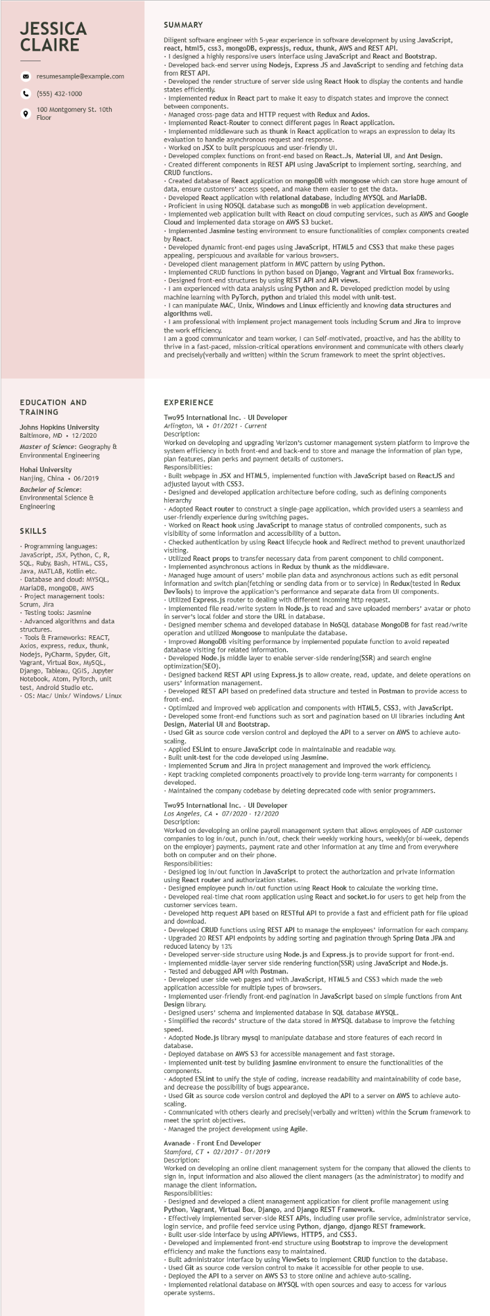
JESSICA CLAIRE
resumesample@example.com
(555) 432-1000
100 Montgomery St. 10th Floor
SUMMARY
Diligent software engineer with 5-year experience in software development by using JavaScript, react, html5, css3, mongoDB, expressjs, redux, thunk, AWS and REST API.
. I designed a highly responsive users interface using JavaScript and React and Bootstrap. •Developed back-end server using Nodejs, Express JS and JavaScript to sending and fetching data from REST API.
Developed the render structure of server side using React Hook to display the contents and handle states efficiently.
•Implemented redux in React part to make it easy to dispatch states and improve the connect between components.
Managed cross-page data and HTTP request with Redux and Axios.
• Implemented React-Router to connect different pages in React application.
• Implemented middleware such as thunk in React application to wraps an expression to delay its evaluation to handle asynchronous request and response.
•Worked on JSX to built perspicuous and user-friendly UI.
Developed complex functions on front-end based on React.Js, Material UI, and Ant Design. Created different components in REST API using JavaScript to implement sorting, searching, and CRUD functions.
Created database of React application on mongoDB with mongoose which can store huge amount of data, ensure customers' access speed, and make them easier to get the data.
Developed React application with relational database, including MYSQL and MariaDB. Proficient in using NOSQL database such as mongoDB in web application development.
Implemented web application built with React on cloud computing services, such as AWS and Google Cloud and implemented data storage on AWS S3 bucket.
Implemented Jasmine testing environment to ensure functionalities of complex components created by React.
Develope
Developed dynamic front-end pages using JavaScript, HTML5 and CSS3 that make these pages appealing, perspicuous and available for various browsers.
Developed client management platform in MVC pattern by using Python.
Implemented CRUD functions in python based on Django, Vagrant and Virtual Box frameworks. Designed front-end structures by using REST API and API views.
• I am experienced with data analysis using Python and R. Developed prediction model by using e learning with PyTorch, python and trialed this model with unit-test.
machine
⚫ I can manipulate MAC, Unix, Windows and Linux efficiently and knowing data structures and algorithms well.
⚫ I am professional with implement project management tools including Scrum and Jira to improve the work efficiency.
I am a good communicator and team worker, I can Self-motivated, proactive, and has the ability to thrive in a fast-paced, mission-critical operations environment and communicate with others clearly and precisely(verbally and written) within the Scrum framework to meet the sprint objectives.
EDUCATION AND TRAINING
Johns Hopkins University Baltimore, MD • 12/2020
Master of Science: Geography &
Environmental Engineering
Hohai University Nanjing, China. 06/2019
Bachelor of Science: Environmental Science & Engineering
SKILLS
• Programming languages: JavaScript, JSX, Python, C, R, SQL, Ruby, Bash, HTML, CSS, Java, MATLAB, Kotlin etc. Database and cloud: MYSQL, MariaDB, mongoDB, AWS Project management tools:
Scrum, Jira
Testing tools: Jasmine
Advanced algorithms and data
structures. tructur
Tools & Frameworks: REACT, Avios
express, redux, thunk,
Nodejs, PyCharm, Spyder, Git, Vagrant, Virtual Box, MySQL, Django, Tableau, QGIS, Jupyter Notebook, Atom, PyTorch, unit test, Android Studio etc.
OS: Mac/ Unix/ Windows/Linux
EXPERIENCE
Two95 International Inc. - UI Developer
Arlington, VA 01/2021 Current
Description:
Worked on developing and upgrading Verizon's customer management system platform to improve the system efficiency in both front-end and back-end to store and manage the information of plan type, plan features, plan perks and payment details of customers.
Responsibilities:
Responsio
Built webpage in JSX and HTML5, implemented function with JavaScript based on ReactJS and adjusted layout with CSS3.
• Designed and developed application architecture before coding, such as defining components hierarchy Adopted React router to construct a single-page application, which provided users a seamless and user-friendly experience during switching pages.
•Worked on React hook using JavaScript to manage status of controlled components, such as visibility of some information and accessibility of a button.
Checked authentication by using React lifecycle hook and Redirect method to prevent unauthorized visiting.
• Utilized React props to transfer necessary data from parent component to child component. • Implemented asynchronous actions in Redux by thunk as the middleware.
Managed huge amount of users' mobile plan data and asynchronous actions such as edit personal
information and swit switch plan(fetching or sending data from or to service) in Redux(tested in Redux DevTools) to improve the application's performance and separate data from UI components. •Utilized Express.js router to dealing with different incoming http request.
• Implemented file read/write system in Node.js to read and save uploaded members' avatar or photo in server's local folder and store the URL in database.
• Designed member schema and developed database in NoSQL database MongoDB for fast read/write operation and utilized Mongoose to manipulate the database.
Improved MongoDB visiting performance by implemented populate function to avoid repeated database visiting for related information.
Developed Node.js middle layer to enable server-side rendering (SSR) and search engine optimization (SEO).
Designed backend REST API using Express.js to allow create, read, update, and delete operations on users' information management.
Developed REST API based on predefined data structure and tested in Postman to provide access to front-end.
Optimized and improved web application and components with HTML5, CSS3, with JavaScript. Developed some front-end functions such as sort and pagination based on UI libraries including Ant Design, Material UI and Bootstrap.
• Used Git as source code version control and deployed the API to a server on AWS to achieve auto- scaling.
Applied ESLint to ensure JavaScript code in maintainable and readable way.
• Built unit-test for the code developed using Jasmine.
• Implemented Scrum and Jira in project management and improved the work efficiency.
Kept tracking completed components proactively to provide long-term warranty for components I developed.
• Maintained the company codebase by deleting deprecated code with senior programmers.
Two95 International Inc. - UI Developer
Los Angeles, CA⚫ 07/2020 - 12/2020
Description:
Worked on developing an online payroll management system that allows employees of ADP customer companies to log in/out, punch in/out, check their weekly working hours, weekly (or bi-week, depends on the employer) payments, payment rate and other information at any time and from everywhere both on computer and on their phone.
Responsibilities:
Responsibilities:
Designed log in/out function in JavaScript to protect the authorization and private information using React router and authorization states.
Designed employee punch in/out function using React Hook to calculate the working time.
•Developed real-time chat room application using React and socket.io for users to get help from the customer services team.
•Developed http request API based on RESTful API to provide a fast and efficient path for file upload and download.
Developed CRUD functions using REST API to manage the employees' information for each company. Upgraded 120 REST API endpoints by adding sorting and pagination through Spring Data JPA and reduced latency by 13%
Developed server-side structure using Node.js and Express.js to provide support for front-end. • Implemented middle-layer server side rendering function (SSR) using JavaScript and Node.js. • Tested and debugged API with Postman.
Developed user side web pages and with JavaScript, HTML5 and CSS3 which made the web application accessible for multiple types of browsers.
Implemented user-friendly front-end pagination in JavaScript based on simple functions from Ant Design library.
Designed users' schema and implemented database in SQL database MYSQL.
Simplified the records' structure of the data stored in MYSQL database to improve the fetching
speed.
speed
Adopted M
I Node.js library mysql to manipulate database and store features of each record in database.
Deployed database on AWS S3 for accessible management and fast storage.
Implemented unit-test by building jasmine environment to ensure the functionalities of the components.
• Adopted ESLint to unify the style of coding, increase readability and maintainability of code base, and decrease the possibility of bugs appearance.
• Used Git as source code version control and deployed the API to a server on AWS to achieve auto-
scaling.
• Communicated with others clearly and precisely(verbally and written) within the Scrum framework to meet the sprint objectives.
• Managed the project development using Agile.
Avanade - Front End Developer
Stamford, CT. 02/2017 - 01/2019
Description:
Worked on developing an online client management system for the company that allowed the clients to sign in, input information and also allowed the client managers (as the administrator) to modify and manage the client information.
Responsibilities:
Designed and developed a client management application for client profile management using Python, Vagrant, Virtual Box, Django, and Django REST Framework.
login service, and profile feed service using Python, django, django REST framework. Built user-side interface by using APIViews, HTTP5, and CSS3.
Effectively implemented server-side REST APIs, including user profile service, administrator service,
Developed and implemented front-end structure using Bootstrap to improve the development efficiency and make the functions easy to maintained.
Built administrator interface by using ViewSets to implement CRUD function to the database.
• Used Git as source code version control to make it accessible for other people to use. Deployed the API to a server on AWS S3 to store online and achieve auto-scaling. Implemented relational database on MYSQL with open sources and easy to access for various operate systems.

